Strongswan 官方配置
https://www.strongswan.org/testing/testresults/ikev2/nat-rw-psk/

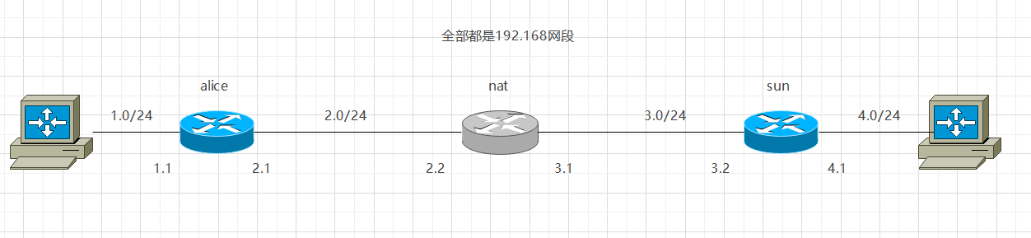
Alice
ens33: flags=4163<UP,BROADCAST,RUNNING,MULTICAST> mtu 1500
inet 192.168.2.1 netmask 255.255.255.0 broadcast 192.168.2.255
inet6 fe80::20c:29ff:fef4:5197 prefixlen 64 scopeid 0x20<link>
ether 00:0c:29:f4:51:97 txqueuelen 1000 (Ethernet)
RX packets 110 bytes 9844 (9.8 KB)
RX errors 0 dropped 0 overruns 0 frame 0
TX packets 278 bytes 20334 (20.3 KB)
TX errors 0 dropped 0 overruns 0 carrier 0 collisions 0

ens37: flags=4163<UP,BROADCAST,RUNNING,MULTICAST> mtu 1500
inet 192.168.1.1 netmask 255.255.255.0 broadcast 192.168.1.255
inet6 fe80::20c:29ff:fef4:51a1 prefixlen 64 scopeid 0x20<link>
ether 00:0c:29:f4:51:a1 txqueuelen 1000 (Ethernet)
RX packets 0 bytes 0 (0.0 B)
RX errors 0 dropped 0 overruns 0 frame 0
TX packets 16 bytes 1216 (1.2 KB)
TX errors 0 dropped 0 overruns 0 carrier 0 collisions 0

需要添加到3.0 网段的路由
route add -net 192.168.3.0/24 gw 192.168.2.2

swanctl 配置文件
connections {

nat-t {
local_addrs = 192.168.2.1
remote_addrs = 192.168.3.2

local {
auth = psk
id = 192.168.2.1
}
remote {
auth = psk
id = 192.168.3.2
}
children {
nat-t {
remote_ts = 192.168.4.0/24
local_ts = 192.168.1.0/24
updown = /usr/local/libexec/ipsec/_updown iptables
esp_proposals = aes128gcm128-x25519
}
}
version = 2
proposals = aes128-sha256-x25519
}
}

secrets {
ike-sun {
id = 192.168.3.2
secret = 0sv+NkxY9LLZvwj4qCC2o/gGrWDF2d21jL
}
}

Nat

ens33: flags=4163<UP,BROADCAST,RUNNING,MULTICAST> mtu 1500
inet 192.168.2.2 netmask 255.255.255.0 broadcast 192.168.2.255
inet6 fe80::20c:29ff:fe96:5fe1 prefixlen 64 scopeid 0x20<link>
ether 00:0c:29:96:5f:e1 txqueuelen 1000 (Ethernet)
RX packets 387 bytes 26910 (26.9 KB)
RX errors 0 dropped 0 overruns 0 frame 0
TX packets 166 bytes 13778 (13.7 KB)
TX errors 0 dropped 0 overruns 0 carrier 0 collisions 0

ens37: flags=4163<UP,BROADCAST,RUNNING,MULTICAST> mtu 1500
inet 192.168.3.1 netmask 255.255.255.0 broadcast 192.168.3.255
inet6 fe80::20c:29ff:fe96:5feb prefixlen 64 scopeid 0x20<link>
ether 00:0c:29:96:5f:eb txqueuelen 1000 (Ethernet)
RX packets 159 bytes 13016 (13.0 KB)
RX errors 0 dropped 0 overruns 0 frame 0
TX packets 333 bytes 23860 (23.8 KB)
TX errors 0 dropped 0 overruns 0 carrier 0 collisions 0

执行 iptables -t nat -A POSTROUTING -s 192.168.2.0/24 -o ens37 -j MASQUERADE

Sun

ens33: flags=4163<UP,BROADCAST,RUNNING,MULTICAST> mtu 1500
inet 192.168.3.2 netmask 255.255.255.0 broadcast 192.168.3.255
inet6 fe80::20c:29ff:fe93:975f prefixlen 64 scopeid 0x20<link>
ether 00:0c:29:93:97:5f txqueuelen 1000 (Ethernet)
RX packets 339 bytes 23878 (23.8 KB)
RX errors 0 dropped 0 overruns 0 frame 0
TX packets 159 bytes 13196 (13.1 KB)
TX errors 0 dropped 0 overruns 0 carrier 0 collisions 0

ens37: flags=4163<UP,BROADCAST,RUNNING,MULTICAST> mtu 1500
inet 192.168.4.1 netmask 255.255.255.0 broadcast 192.168.4.255
inet6 fe80::20c:29ff:fe93:9769 prefixlen 64 scopeid 0x20<link>
ether 00:0c:29:93:97:69 txqueuelen 1000 (Ethernet)
RX packets 0 bytes 0 (0.0 B)
RX errors 0 dropped 0 overruns 0 frame 0
TX packets 16 bytes 1216 (1.2 KB)
TX errors 0 dropped 0 overruns 0 carrier 0 collisions 0

swanctl.conf

connections {

nat-t {
local_addrs = 192.168.3.2

local {
auth = psk
id = 192.168.3.2
}
remote {
auth = psk
}
children {
nat-t {
local_ts = 192.168.4.0/24
remote_ts = 192.168.1.0/24

updown = /usr/local/libexec/ipsec/_updown iptables
esp_proposals = aes128gcm128-x25519
}
}
version = 2
proposals = aes128-sha256-x25519
}
}

secrets {
ike-alice {
id = 192.168.2.1
secret = 0sv+NkxY9LLZvwj4qCC2o/gGrWDF2d21jL
}
}

配置完成后
Alice和Sun 分别执行
systemctl restart strongswan
swanctl --load-all

root@server:/etc/swanctl# swanctl --load-all
no files found matching '/etc/swanctl/conf.d/*.conf'
loaded ike secret 'ike-sun'
no authorities found, 0 unloaded
no pools found, 0 unloaded
loaded connection 'nat-t'
successfully loaded 1 connections, 0 unloaded

在Alice执行 ipsec up nat-t 结果如下所示

root@server:/etc/swanctl# ipsec up nat-t
initiating IKE_SA nat-t[2] to 192.168.3.2
generating IKE_SA_INIT request 0 [ SA KE No N(NATD_S_IP) N(NATD_D_IP) N(FRAG_SUP) N(HASH_ALG) N(REDIR_SUP) ]
sending packet: from 192.168.2.1[500] to 192.168.3.2[500] (240 bytes)
received packet: from 192.168.3.2[500] to 192.168.2.1[500] (248 bytes)
parsed IKE_SA_INIT response 0 [ SA KE No N(NATD_S_IP) N(NATD_D_IP) N(FRAG_SUP) N(HASH_ALG) N(CHDLESS_SUP) N(MULT_AUTH) ]
selected proposal: IKE:AES_CBC_128/HMAC_SHA2_256_128/PRF_HMAC_SHA2_256/CURVE_25519
local host is behind NAT, sending keep alives
authentication of '192.168.2.1' (myself) with pre-shared key
establishing CHILD_SA nat-t{3}
generating IKE_AUTH request 1 [ IDi N(INIT_CONTACT) IDr AUTH SA TSi TSr N(MOBIKE_SUP) N(ADD_4_ADDR) N(ADD_4_ADDR) N(ADD_4_ADDR) N(MULT_AUTH) N(EAP_ONLY) N(MSG_ID_SYN_SUP) ]
sending packet: from 192.168.2.1[4500] to 192.168.3.2[4500] (304 bytes)
received packet: from 192.168.3.2[4500] to 192.168.2.1[4500] (256 bytes)
parsed IKE_AUTH response 1 [ IDr AUTH SA TSi TSr N(MOBIKE_SUP) N(ADD_4_ADDR) N(ADD_4_ADDR) N(ADD_4_ADDR) ]
authentication of '192.168.3.2' with pre-shared key successful
IKE_SA nat-t[2] established between 192.168.2.1[192.168.2.1]...192.168.3.2[192.168.3.2]
scheduling rekeying in 13288s
maximum IKE_SA lifetime 14728s
selected proposal: ESP:AES_GCM_16_128/NO_EXT_SEQ
CHILD_SA nat-t{3} established with SPIs cae5880b_i cd2b5f62_o and TS 192.168.1.0/24 === 192.168.4.0/24
connection 'nat-t' established successfully

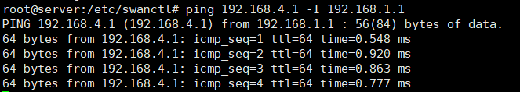
可ping通对端私网ip

在sun抓4500端口包
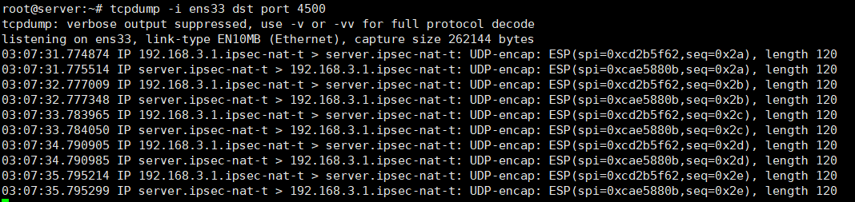
可证实经过nat-t

